**12/11/2024** **GEEKS FOR GEEKS PROBLEMS** **FIZA THASHIN A (AI&DS)**

**1)**

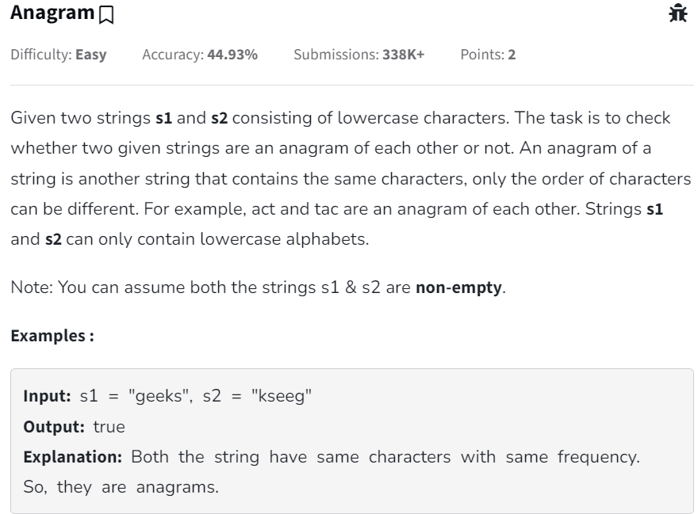

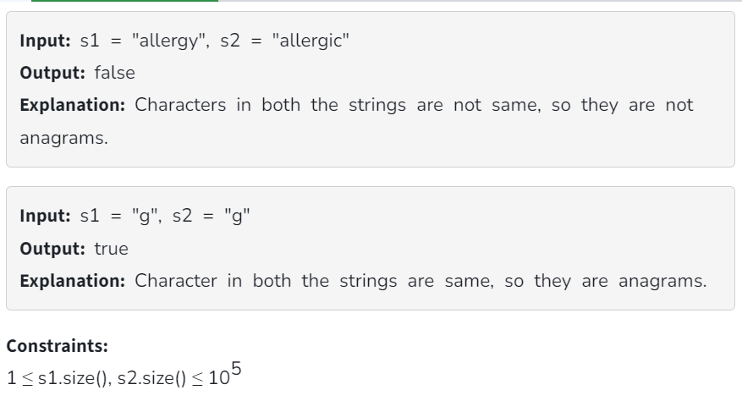

**SOLUTION**

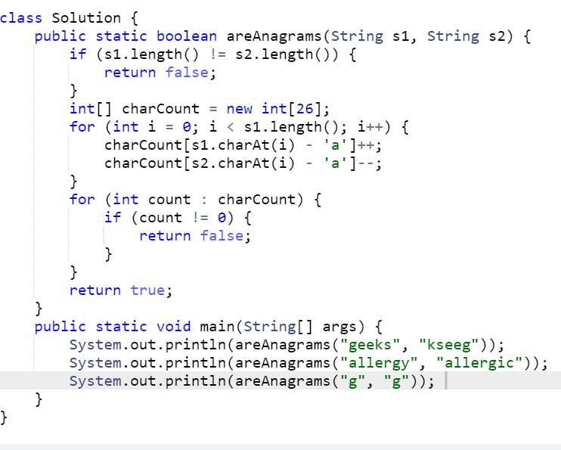

**OUTPUT**

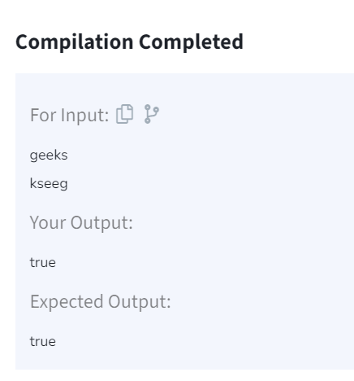

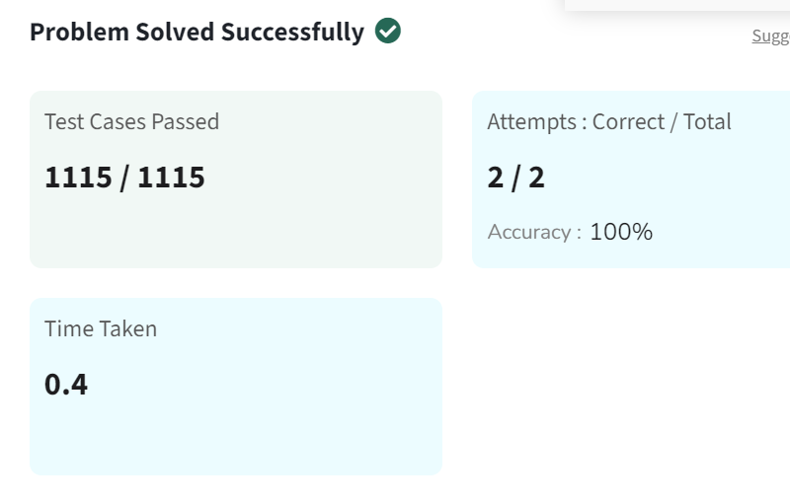

**TIME COMPLEXITY**

**O(n) -** where n is the length of the strings.

**2)**

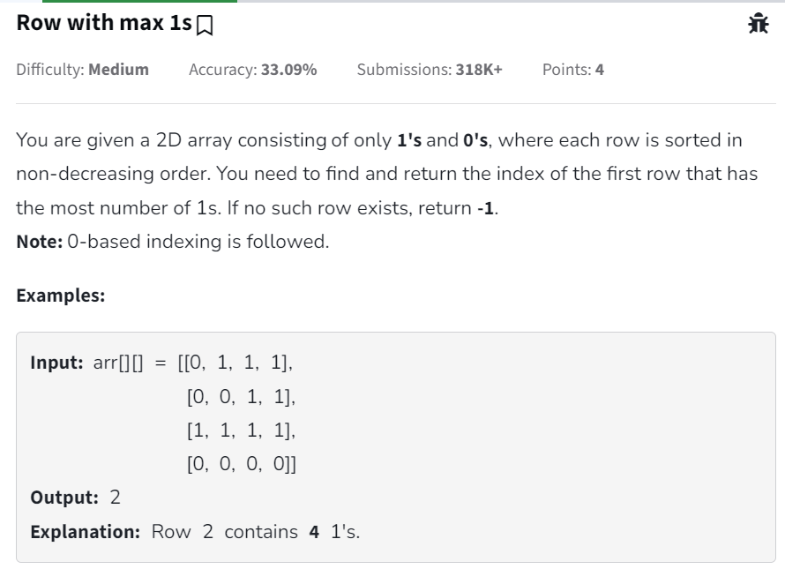

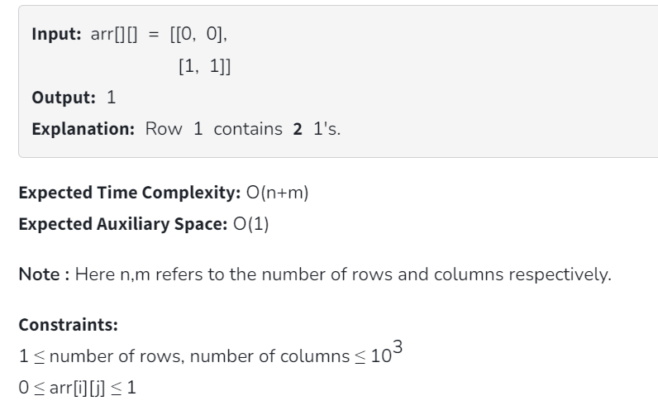

**SOLUTION**

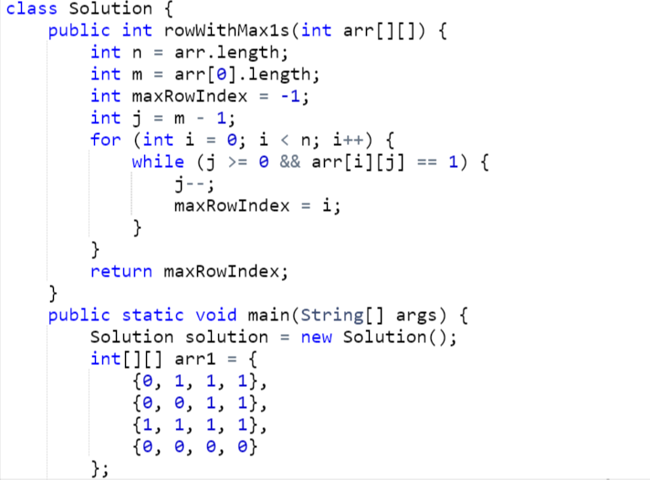

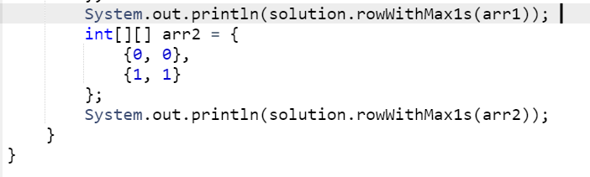

**OUTPUT**

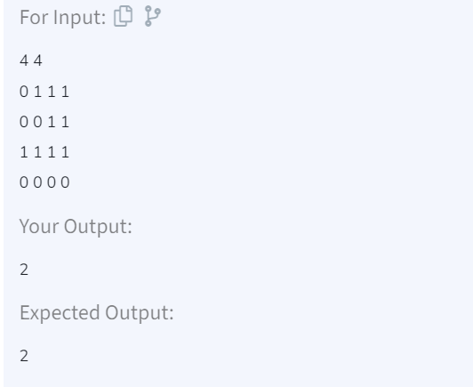

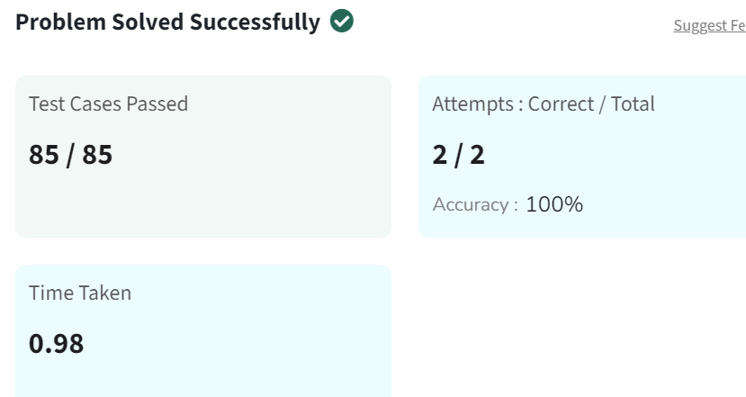

**TIME COMPLEXITY**

**O(n + m) -** The outer loop runs n times, and the inner loop in total runs at most m times for all rows combined.

**3)**

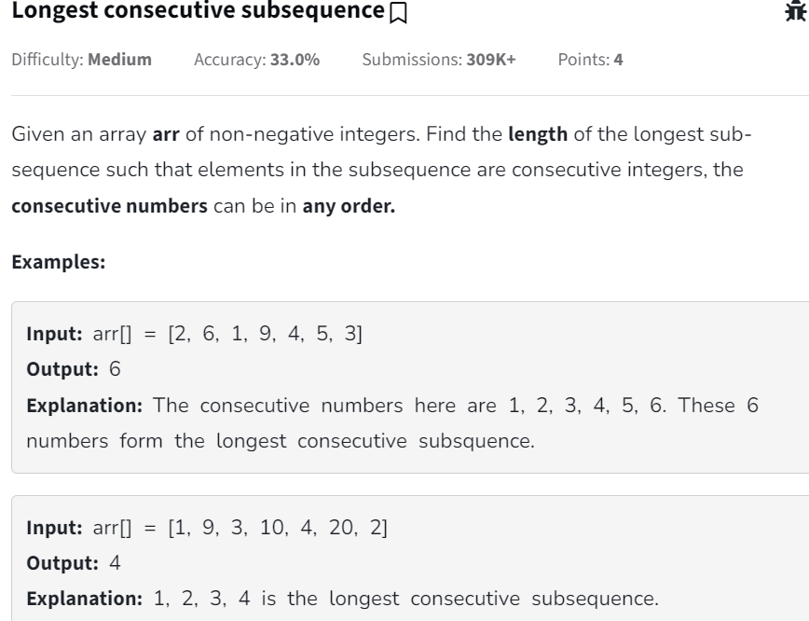

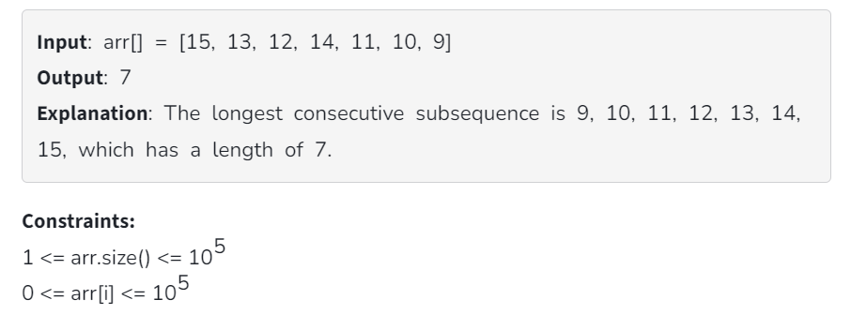

**SOLUTION**

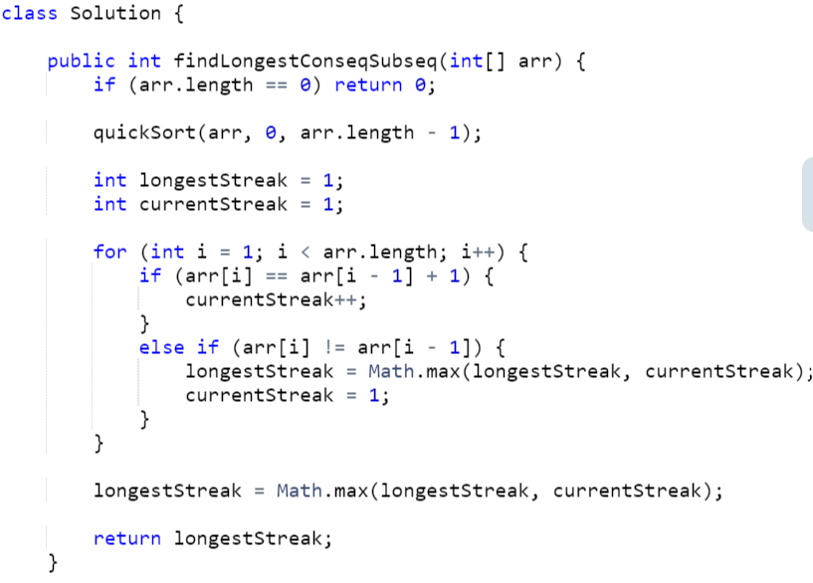

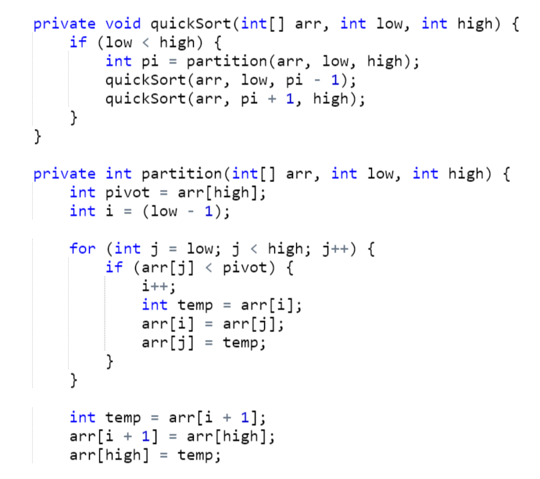

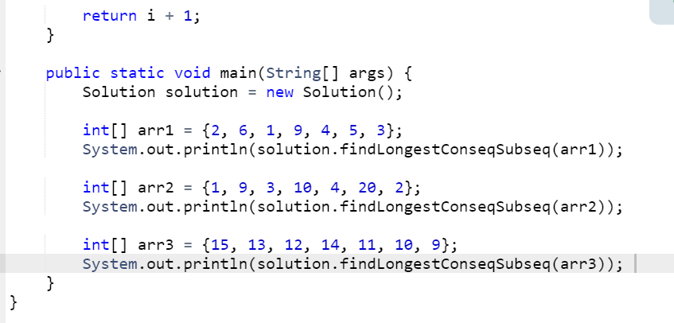

**OUTPUT**

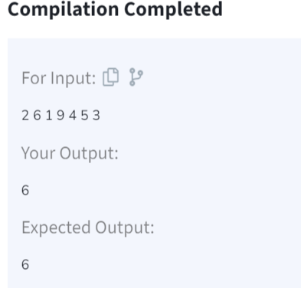

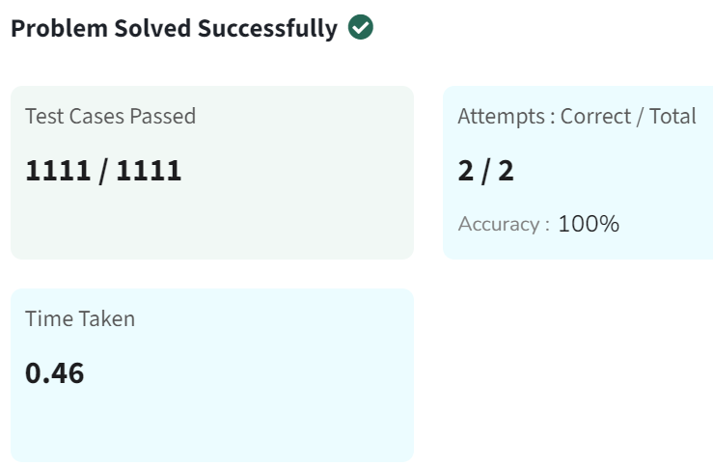

**TIME COMPLEXITY**

**O(n log n) -** The average time complexity of QuickSort is O(n log n), where n is the number of elements in the array**.**

**4)**

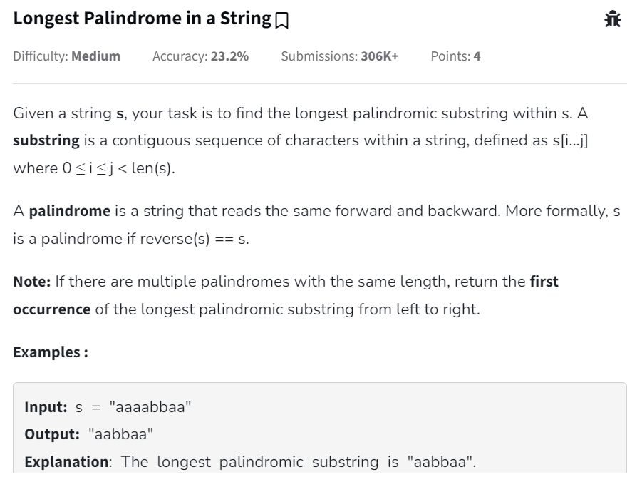

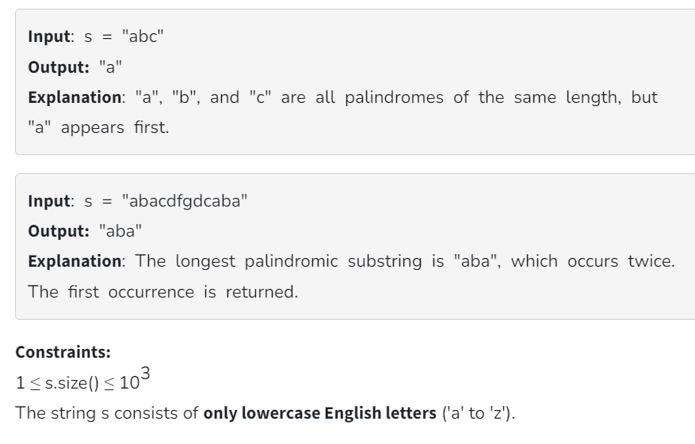

**SOLUTION**

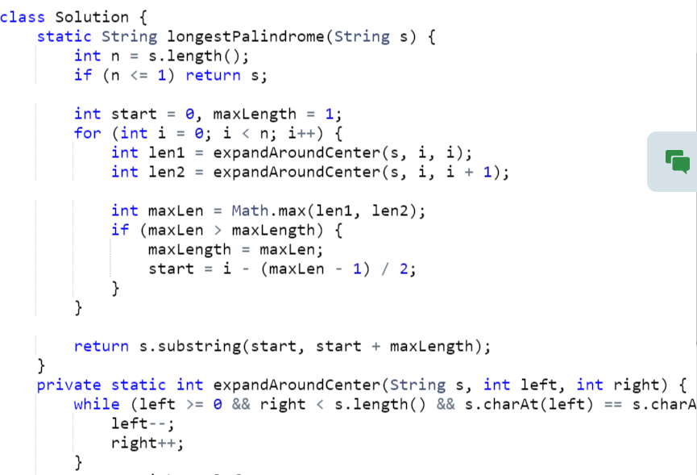

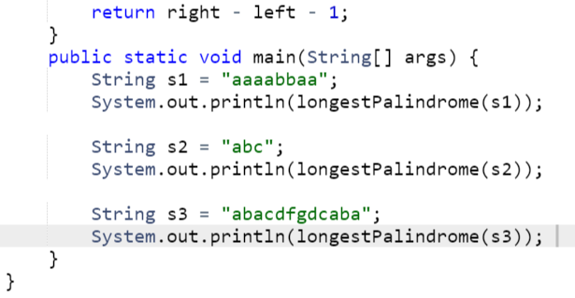

**OUTPUT**

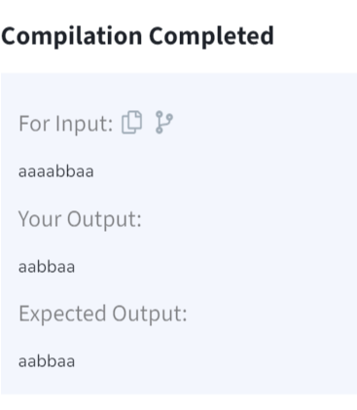

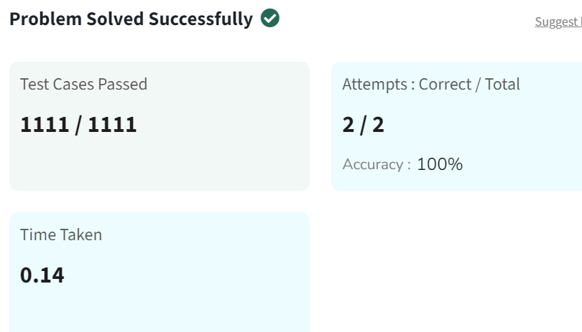

**TIME COMPLEXITY**

**O(n^2) -** because for each of the n characters, the algorithm performs an O(n) expansion to check the palindrome.

**5)**

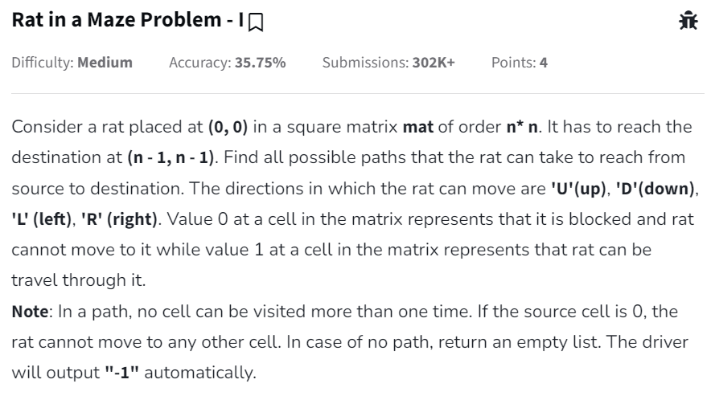

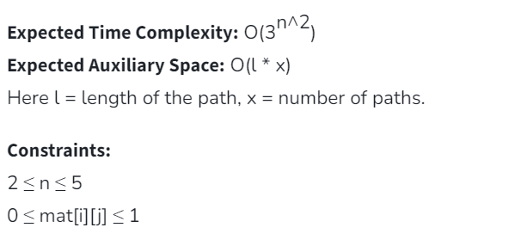

**SOLUTION**

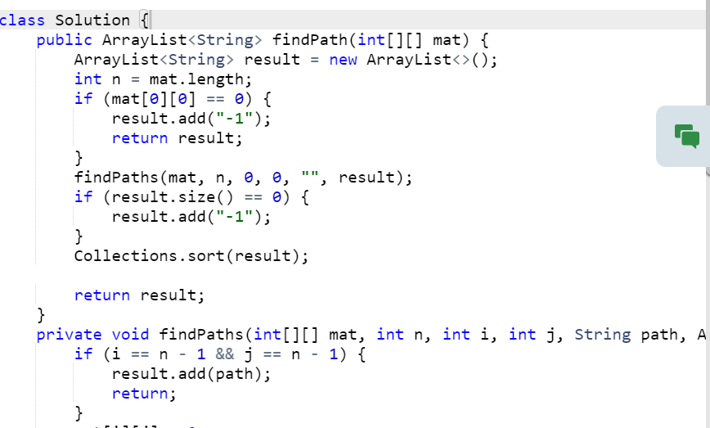

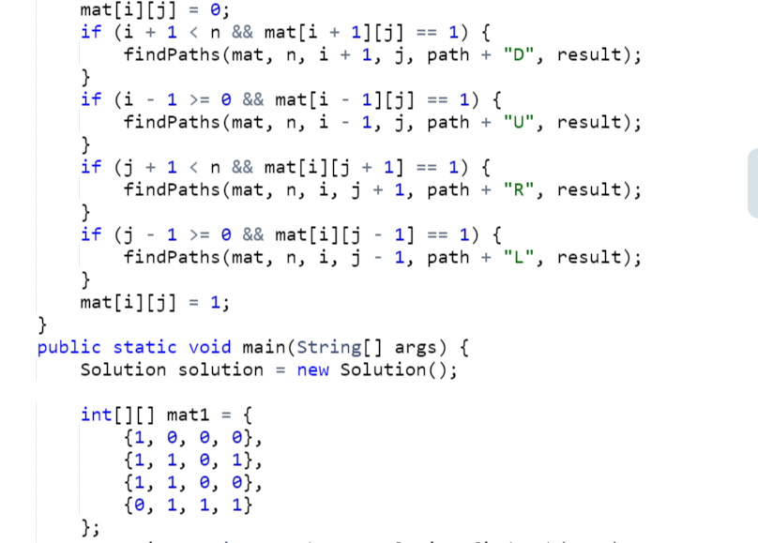

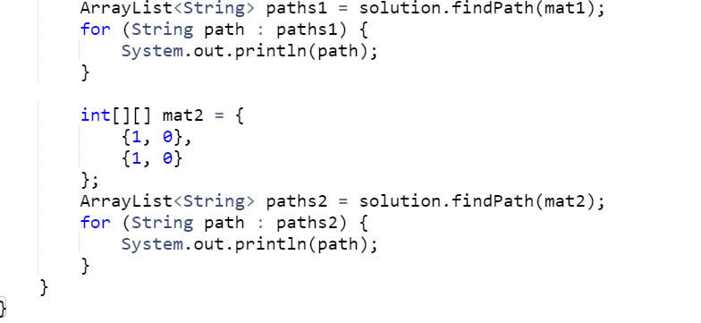

**OUTPUT**

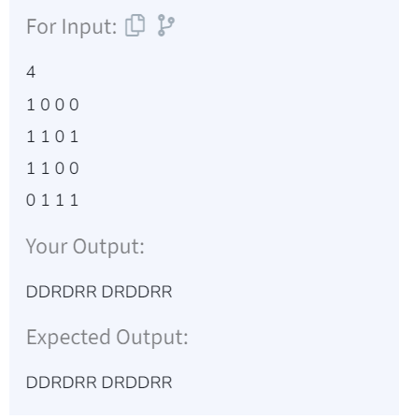

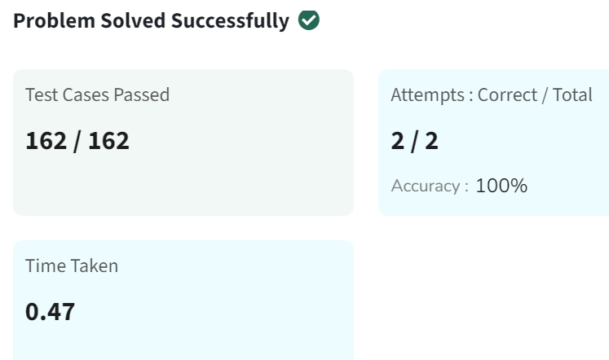

**TIME COMPLEXITY: O(4^n * n log n)**